MEMORANDUM
TO: Strengthening University-Wide Interdisciplinarity Task Force

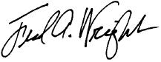
FROM: Fred Wright
Director, Bioinformatics Research Center
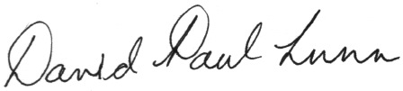
D. Paul Lunn
Dean, College of Veterinary Medicine

CC: Kelly Wick
SUBJECT: Agenda for March 20, 2020 meeting at 3-3:30 p.m.
DATE: March 18, 2020

We propose the following agenda for our forthcoming meeting:
- Approval of February 28 meeting minutes
- Review Interdisciplinarity (ID) definition proposed by sub-group
- Sub-group assignments and charge
- Next meeting date: April 3 from 3-5 p.m. via Zoom

